

Cloud Computing Lab

Submitted to:
Engr. Muhammad Shoaib
Submitted by:
Hania Akbar
Reg no:
2023-BSE-026
Section:
A

Lab #02

Lab Title:
Hands-On Git & Version Control Lab

Task 1: Create Private GitHub Repository
- Create a new private repository named Lab2 on GitHub.
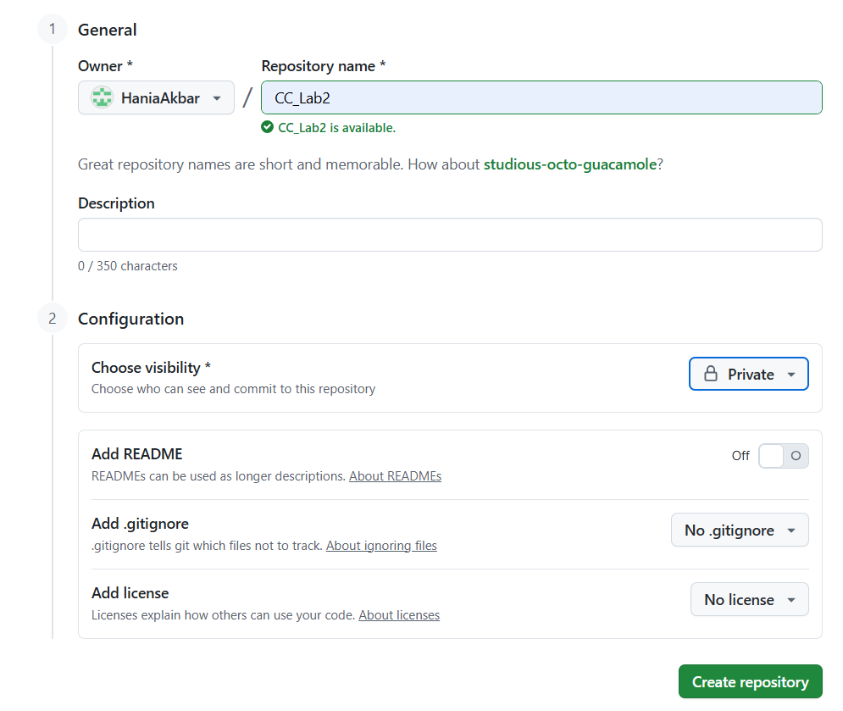

Task 2: Connect Repository via SSH
- Generate a new SSH key using PowerShell:
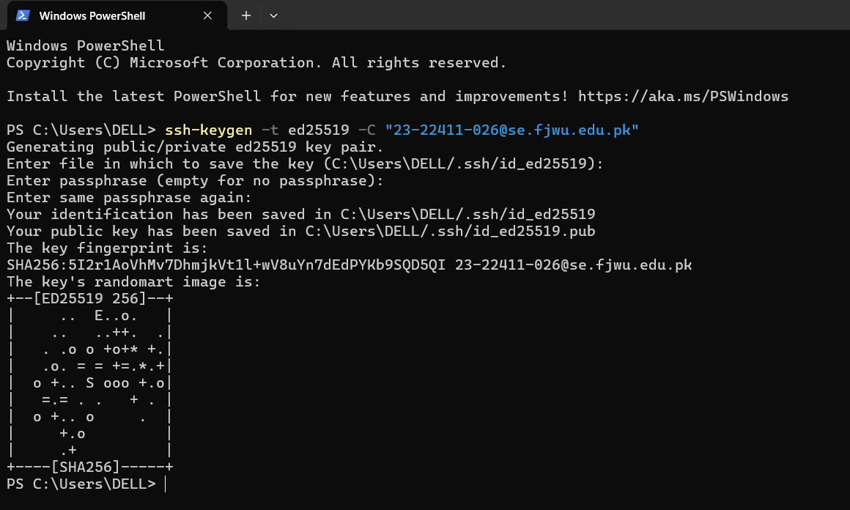
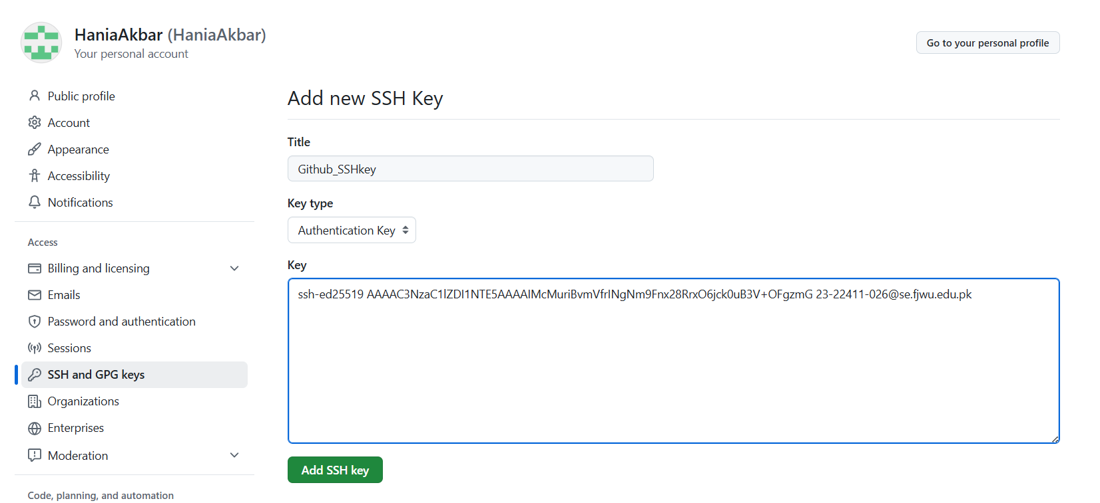
- Add your SSH public key to GitHub (Settings > SSH and GPG keys).

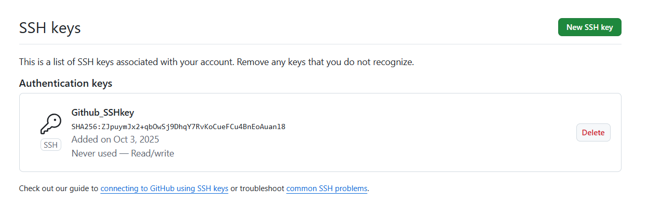
- Clone your Lab2 repo using SSH.
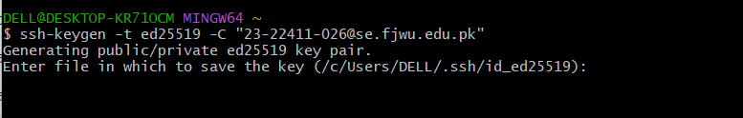
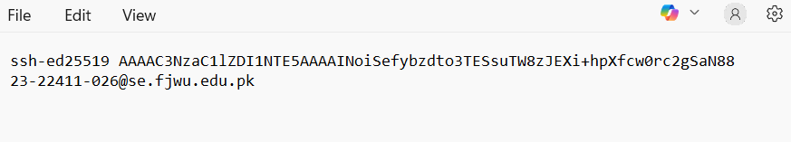

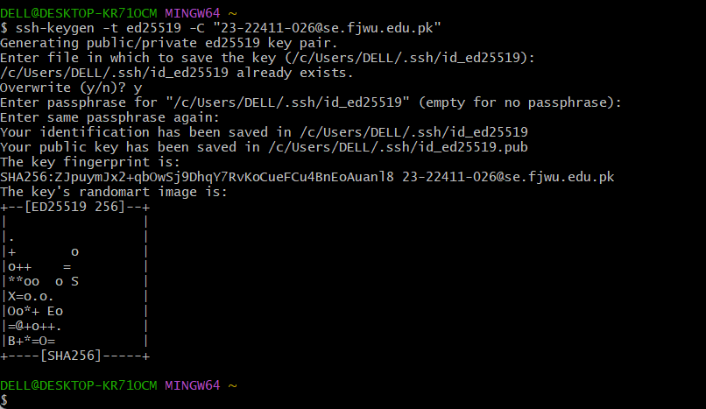
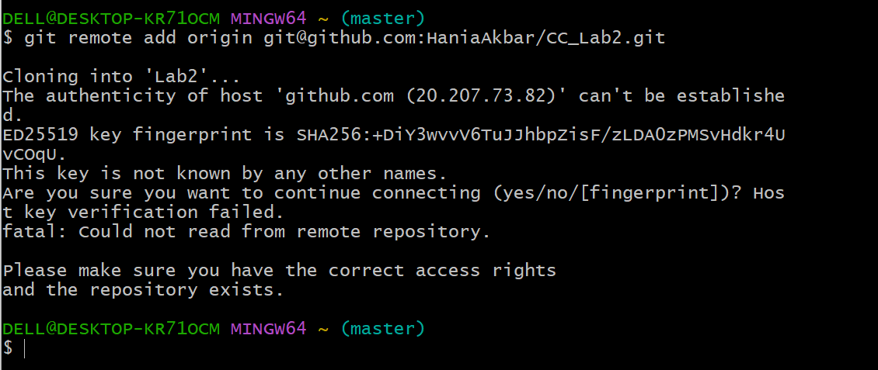

Task 3: Configure Git Username and Email
- Set up your Git identity (this ensures all commits are linked to you):
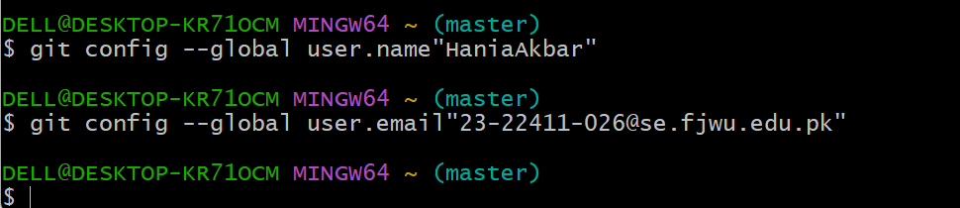
- Verify your configuration:
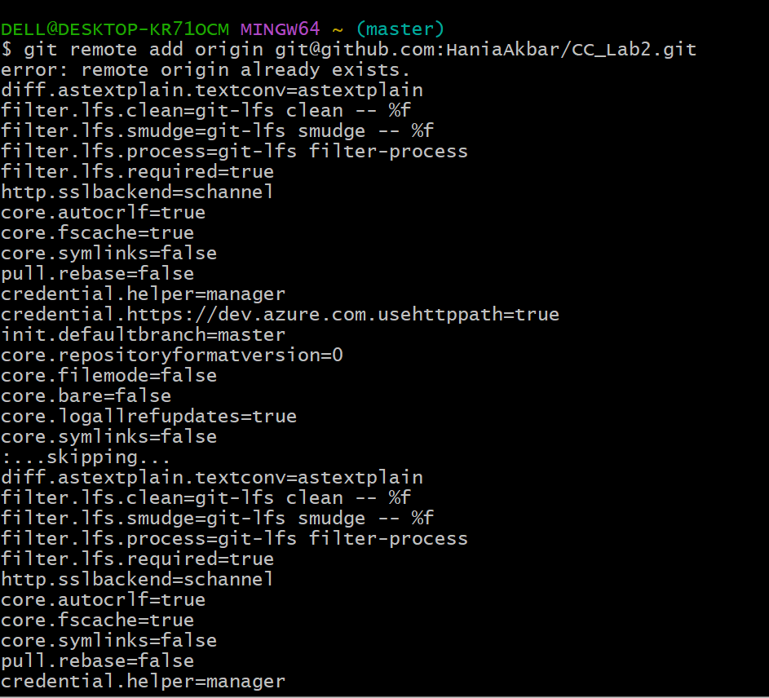

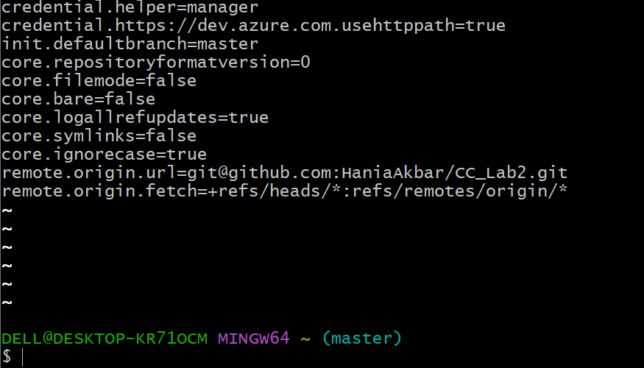

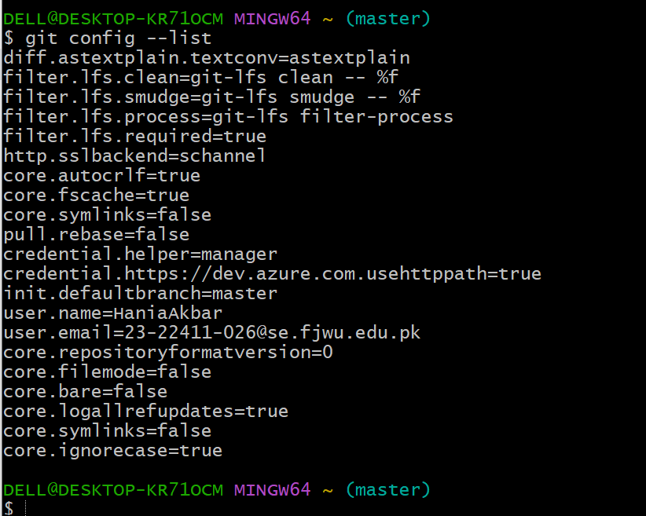

Task 4: Explore the .git Folder
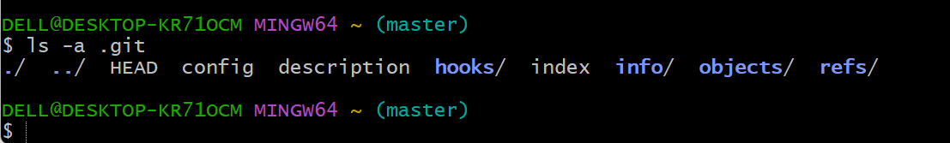

Task 5: Local Repository Management
- Delete the existing .git folder from your cloned repo using Git Bash:
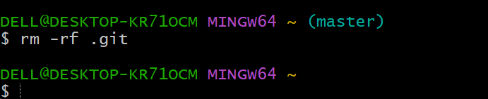
- Re-initialize the local git repository:
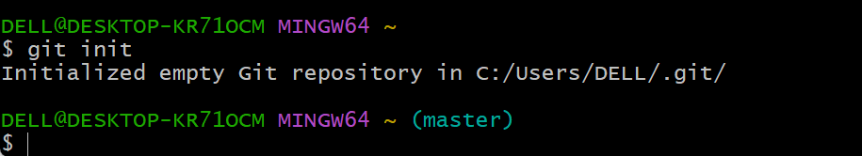
- Add a file named README.md and commit it:
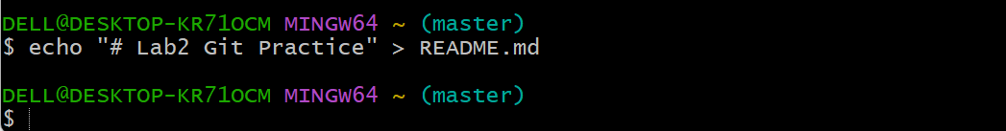
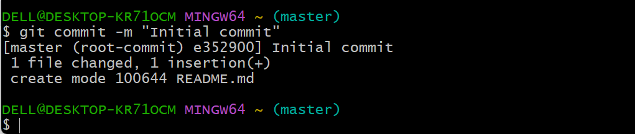
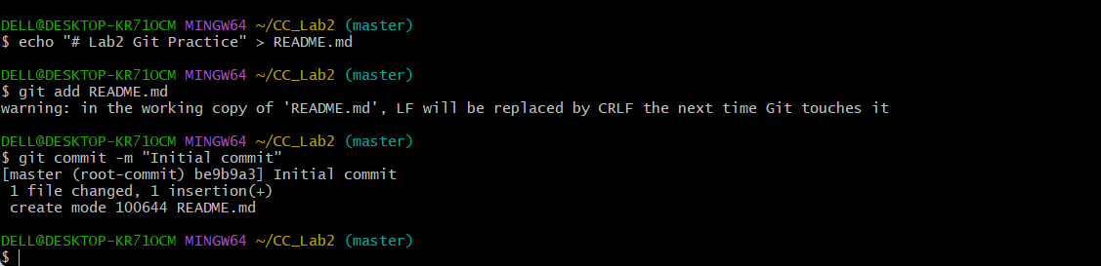
- Connect your local repo to GitHub and push:
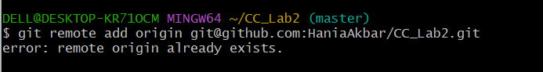
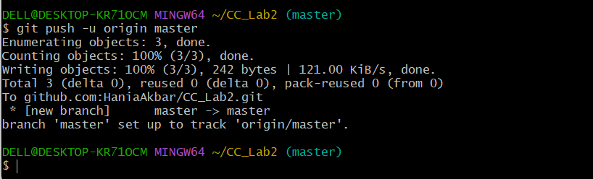

Task 6: File Status & Staging

Create a new file notes.txt and write a note.
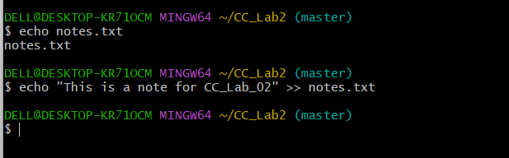

Check status:

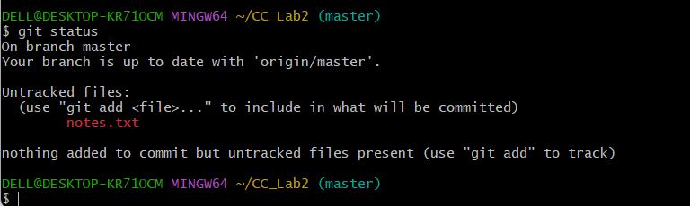

Stage and commit:
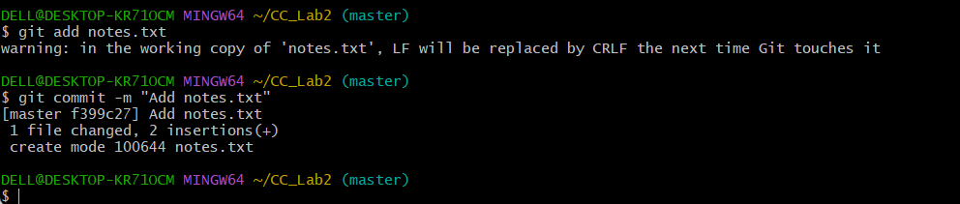

Edit notes.txt and repeat status/commit steps.
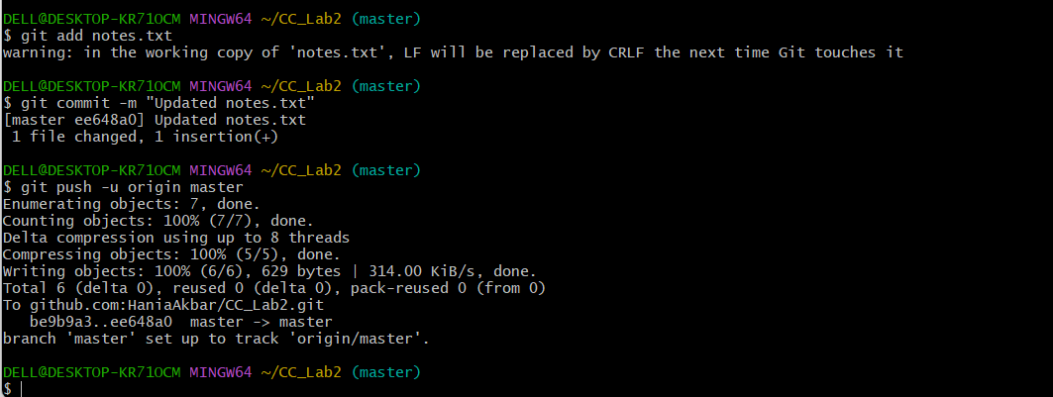

Task 7: Branch Creation Using GitHub GUI
- On GitHub (web interface), create a branch named bugfix/user-auth-error.

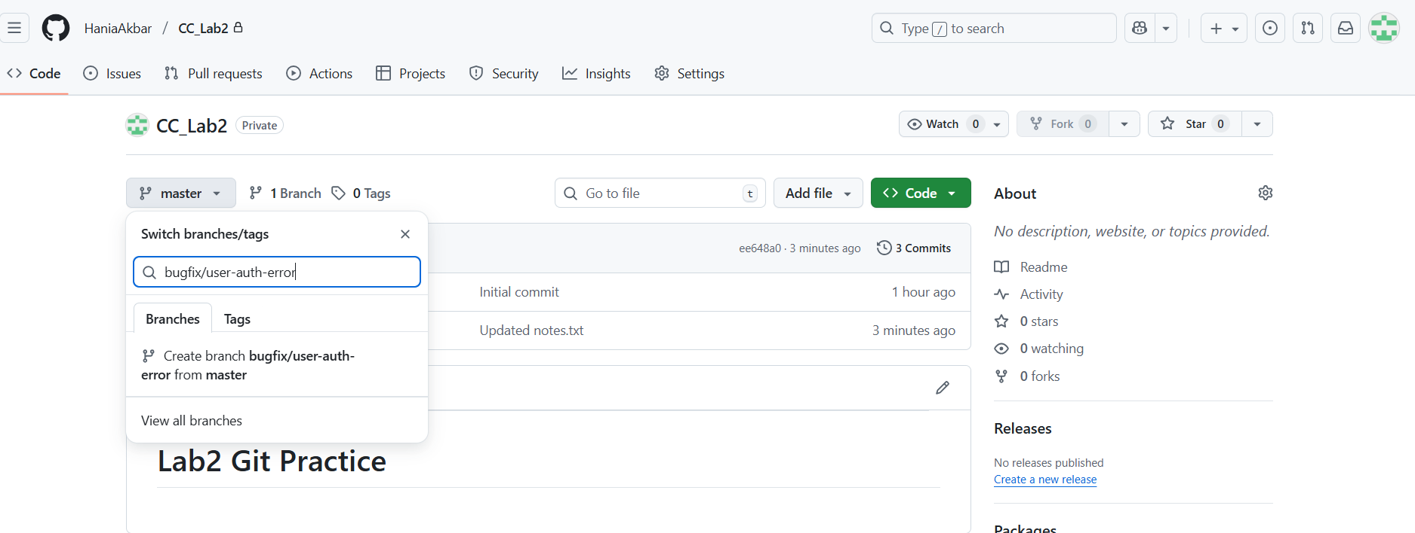
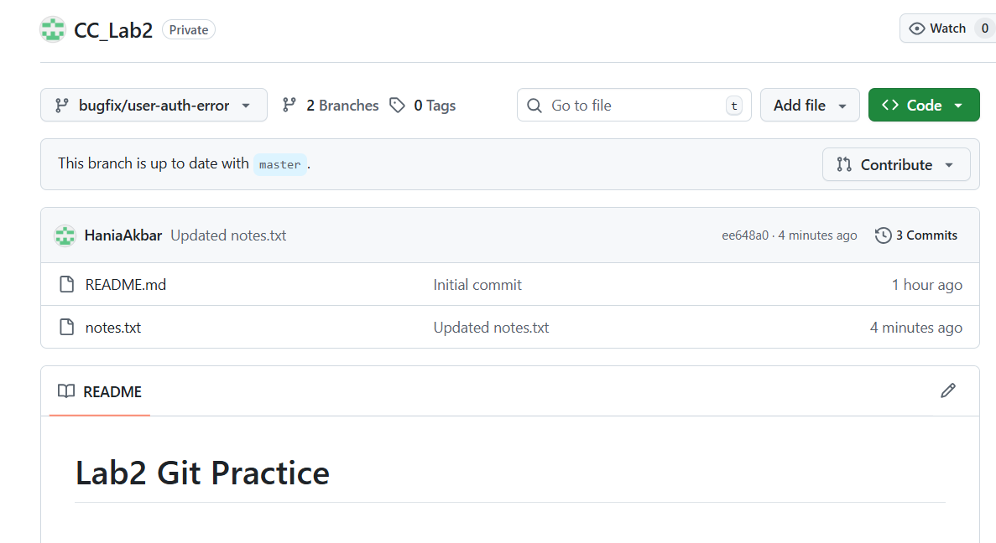
- Pull the branch to your local repository to sync.
- git pull origin bugfix/user-auth-error
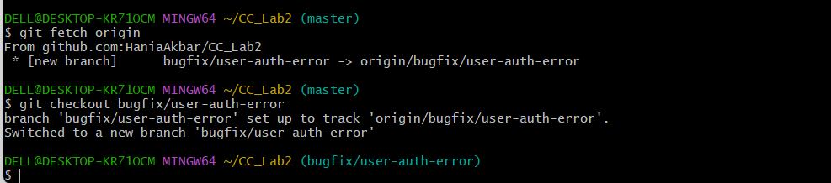

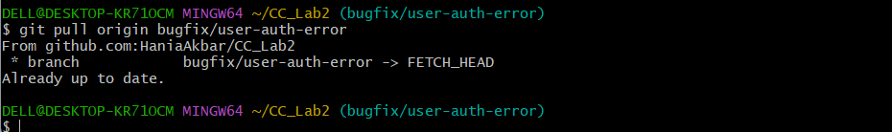

Task 8: Branch Creation and Push Using Git Bash
Create a branch named feature/db-connection using Git Bash:
git checkout -b feature/db-connection
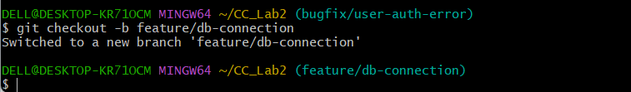
Push the branch to the remote repository:
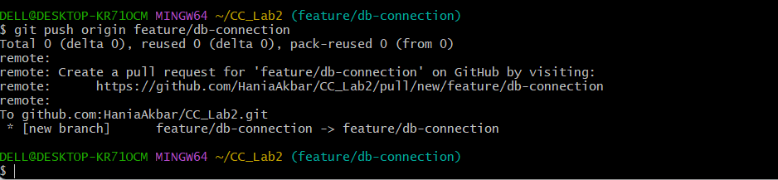

Task 9: Branching & Merging
- Create and switch to a branch feature-1:
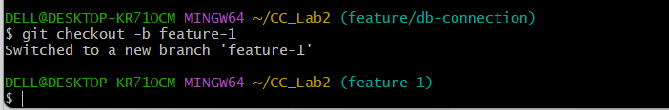
- Modify main.py (add a function) and commit.

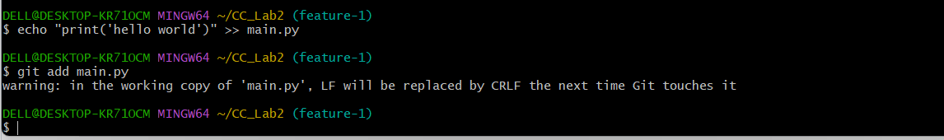
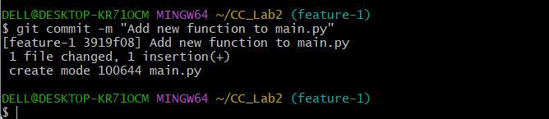

- Switch back to main and merge:

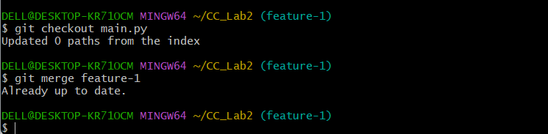

- Push all branches:

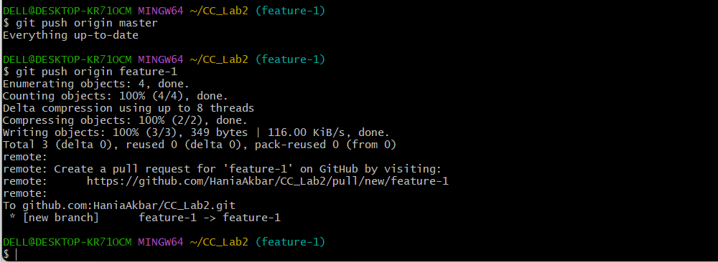

Task 10: Pull Request and Branch Review (GitHub GUI)

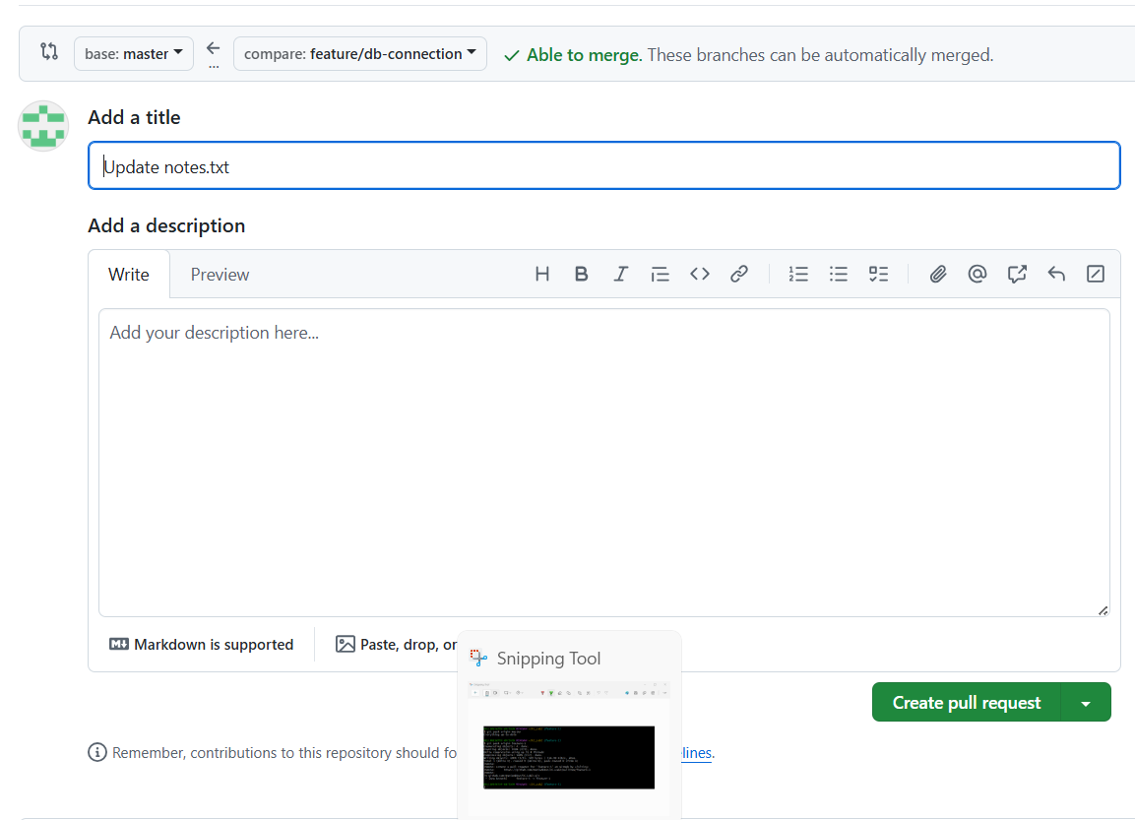

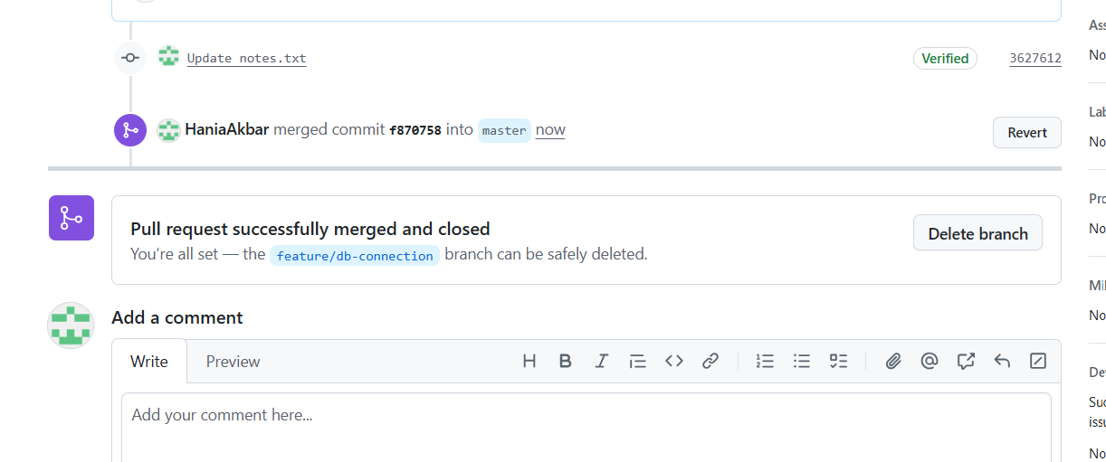

Task 11: Detailed Branch Strategy (Develop/Staging)

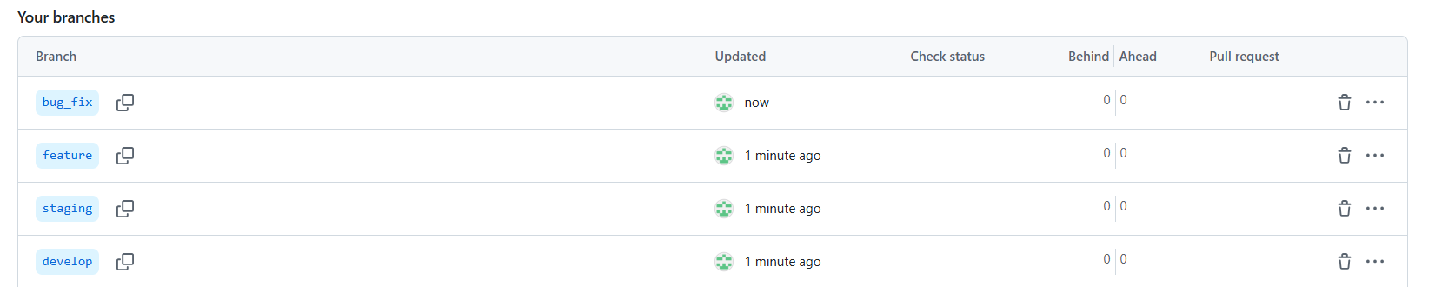

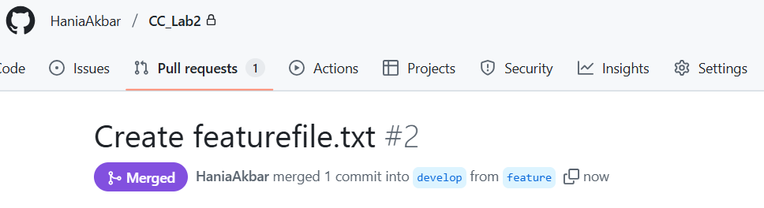

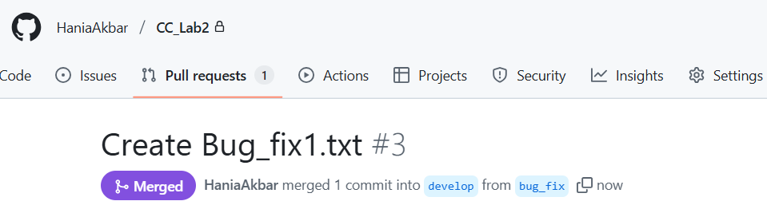
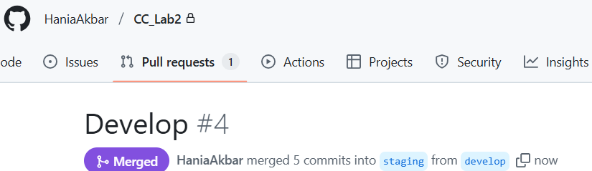
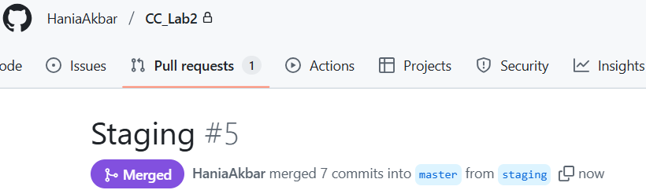

Task 12: Code Review Workflow
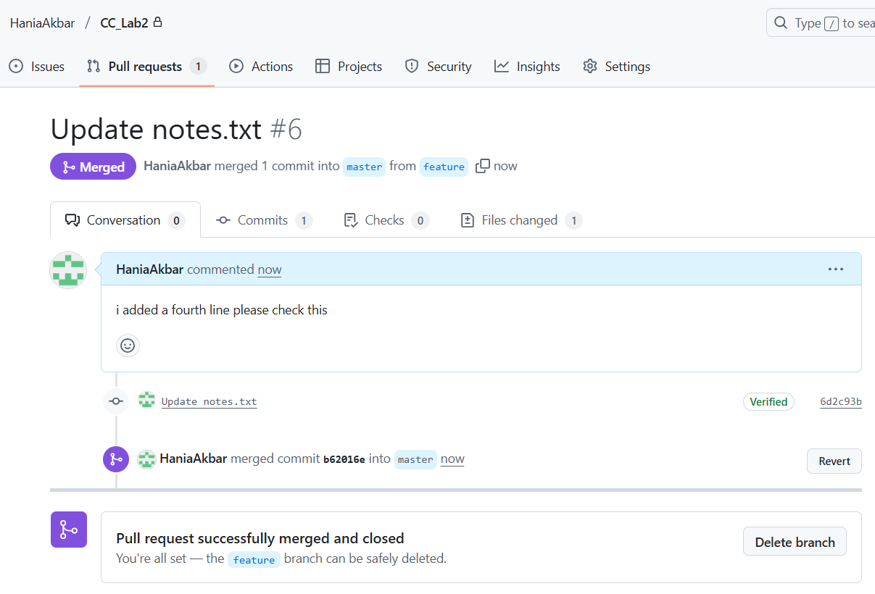

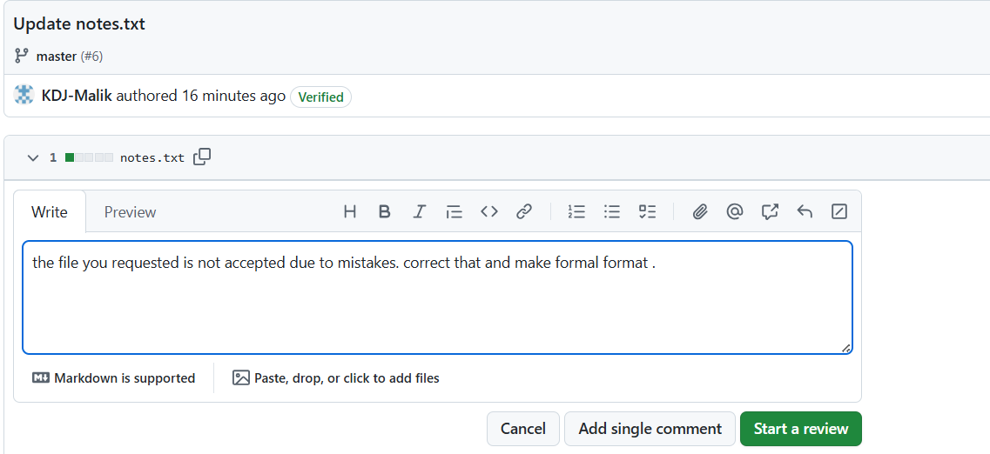
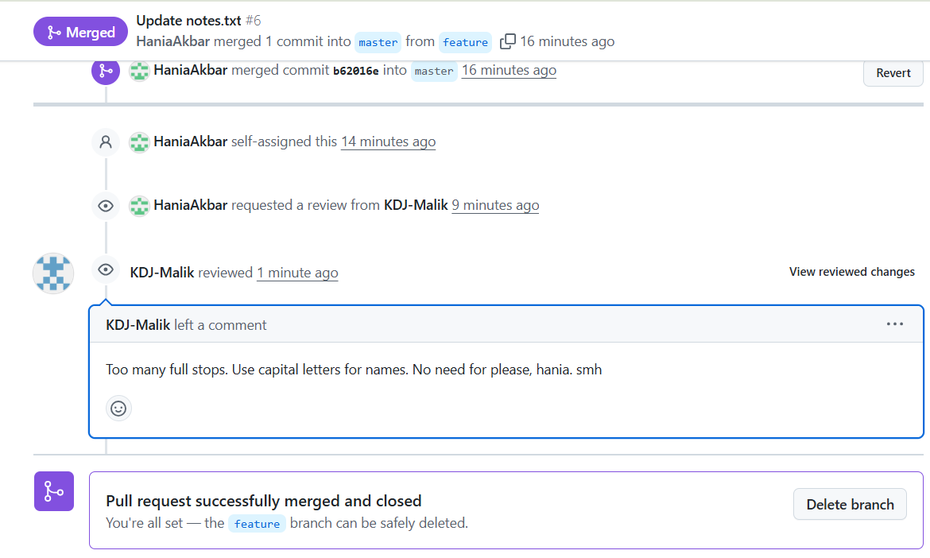
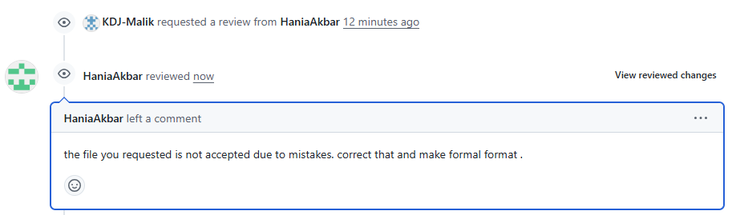
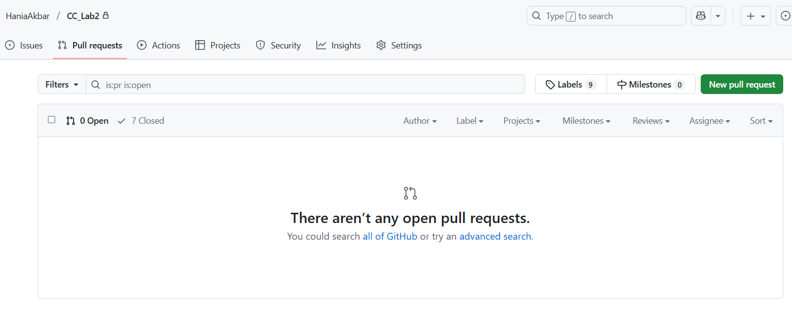

Task 13: Branch Cleanup Best Practices

